Learning from Data Homework 6

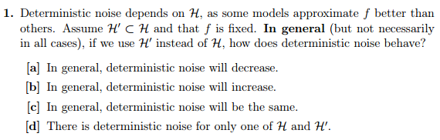

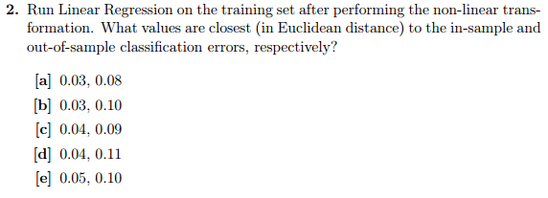

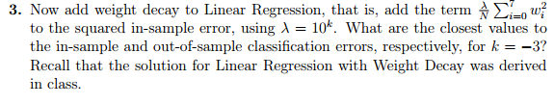

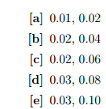

Performance out of sample improved from 0.84 to 0.8, but it is still closest to the exact same pair.

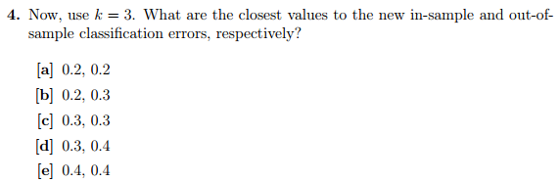

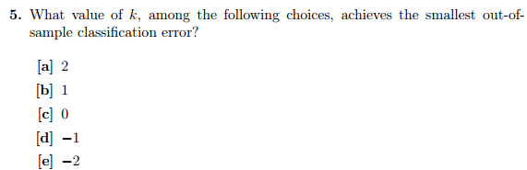

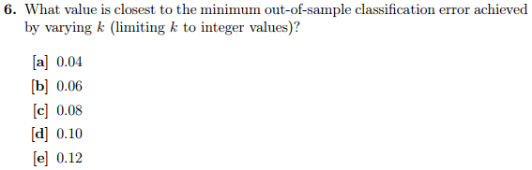

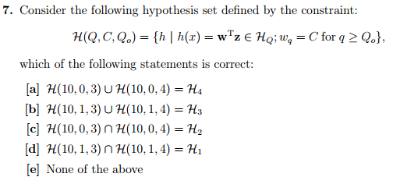

Correction: Thought $∩$ was $∪$ when dismissing C. Correct answer is C.

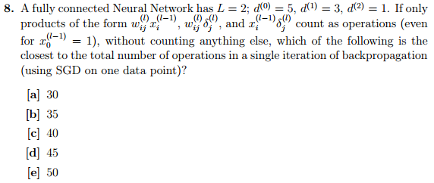

Notation: [source](http://web.cs.swarthmore.edu/~meeden/cs81/s10/BackPropDeriv.pdf)

$a_{x}$ is the activation amount put into nodes in layer $x$

$δ_{x}$ is the product of error and the derivation of the activation function in layer $x$

$w_{xy}$ is the weight of an output from layer $x$ to layer $y$

$i$ is the input layer

$k$ is the hidden layer

$j$ is the output layer

|  |  |
| --- | --- |
| # | Reasoning behind adding |
| 1 | $d^{(2)}$’s $Δw=ϵδ_{k}a_{k}$ (1 node in this layer) |
| 3 | $d^{(1)}$’s nodes $δ_{j}=δ_{k}w_{kj}$. $j$ can only map to 1 node, but $k$ can map to 3 (all nodes on layer 1), so 3*1 |
| 3 | $d^{(1)}$’s nodes $Δw=δ_{j}a_{j}$. $j$ can map to 3 nodes, $i$ to 1 per node |
| 15 | $d^{(0)}$’s nodes $δ_{i}=δ_{j}w_{ji}$. $j$ maps to 3, $i$ to 5. $3*5=15$ |
| 15 | $d^{(0)}$’s nodes $Δw=δ_{i}a_{i}$. $j$ can map to 3 nodes, $i$ to 5 per node. $3*5=15$ |
| 37 | Sum |

Correction: I forgot to include the 8 $a*w$ operations necessary to compute the output before SGD can be done (which is nonetheless part of the iteration). $37 + 8 = 45$, D

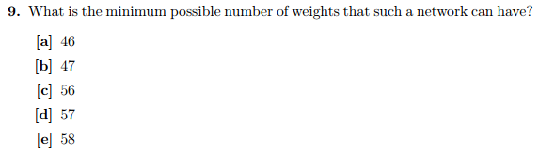

$L=19$ with inputs at $l=0$, hidden layer starting at $l=1$, and outputs at $l=19$. 2 hidden nodes per layer, including the intercept node $x_{0}^{l}$. $10*1 + 2*1*18 = 46$. 10 = # of nodes in input, 1 = # of nodes in every layer receiving activation, 2 = # of nodes sending activation in every layer, 18 = # of connections between two layers with 2 nodes sending and one receiving node in both.

$L=37$ is not possible because then one couldn’t have a neural network (one couldn’t have intercept nodes and traditional nodes in each hidden/input layer)

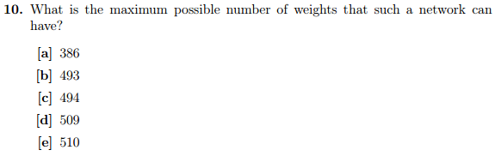

$$\left|W\right|=\left\{\begin{aligned}10\left(x_{2}-1\right)+{\left(x_{2}-1\right)}^{2}\left(\frac{36}{x}-1\right)+\left(\frac{36}{x}-1\right)\left(x_{2}-1\right)+x x≤16 \\ 10\left(x_{2}-1\right)+\left(x_{2}-1\right)\left(36-x_{2}-1\right)+36-x_{2}-1+x_{3} x>16\end{aligned}\right.$$

The above equation represents the number of weights in a neural network described by the specifications of the problem assuming that if you have fewer than 17 nodes per layer, you have the *same* number of nodes per layer. Latter assumption isn’t necessarily true, but seems to not impact the max configuration

$|W|$ reaches its maximum at $x_{2}=22$ with 510 weights.

Homework 6 Solutions

8/10 on first try

Incorrect Problems:

* #7, misunderstood notation (silly mistake, took $∩$ as $∪$)
* #8, forgot to include operations necessary to compute output before backpropagation begins

